ASSIGNMENT NO. 8 — Views and Data Abstraction

Objective: To create and use views, simplify queries, filter reports, and understand data abstraction.

Q1) Create CollegeDB with Course and Student tables and insert 4 courses and 10 students.

Column Name | Data Type | Constraint
CourseID | INT | PRIMARY KEY
CourseName | VARCHAR(50) | NOT NULL
Fees | DECIMAL(10,2) | NOT NULL

Column Name | Data Type | Constraint
StudentID | INT | PRIMARY KEY
StudentName | VARCHAR(50) | NOT NULL
CourseID | INT | FOREIGN KEY
City | VARCHAR(30)
Marks | INT
Email | VARCHAR(60)

CREATE DATABASE CollegeDB_Assignment8;
USE CollegeDB_Assignment8;

-- Create Course Table
CREATE TABLE Course (
CourseID INT PRIMARY KEY,
CourseName VARCHAR(50) NOT NULL,
Fees DECIMAL(10,2) NOT NULL
);

-- Create Student Table
CREATE TABLE Student (
StudentID INT PRIMARY KEY,
StudentName VARCHAR(50) NOT NULL,
CourseID INT,
City VARCHAR(30),
Marks INT,
Email VARCHAR(60),
FOREIGN KEY (CourseID) REFERENCES Course(CourseID)
);

-- Insert 4 Course Records
INSERT INTO Course (CourseID, CourseName, Fees) VALUES
(101, 'BSc IT', 45000.00),
(102, 'BCA', 40000.00),
(103, 'BSc CS', 42000.00),
(104, 'Data Science', 55000.00);

-- Insert 10 Student Records
INSERT INTO Student (StudentID, StudentName, CourseID, City, Marks, Email) VALUES
(1, 'Rahul Sharma', 101, 'Mumbai', 78, 'rahul@gmail.com'),
(2, 'Priya Patil', 102, 'Pune', 85, 'priya@gmail.com'),
(3, 'Aman Verma', 103, 'Nashik', 67, 'aman@gmail.com'),
(4, 'Sneha Joshi', 101, 'Mumbai', 91, 'sneha@gmail.com'),
(5, 'Karan Mehta', 102, 'Thane', 74, 'karan@gmail.com'),
(6, 'Neha Shah', 101, 'Pune', 88, 'neha@gmail.com'),
(7, 'Rohan Desai', 103, 'Mumbai', 69, 'rohan@gmail.com'),
(8, 'Meera Kulkarni', 102, 'Nashik', 82, 'meera@gmail.com'),
(9, 'Arjun Nair', 101, 'Thane', 59, 'arjun@gmail.com'),
(10, 'Divya More', 102, 'Mumbai', 93, 'divya@gmail.com');

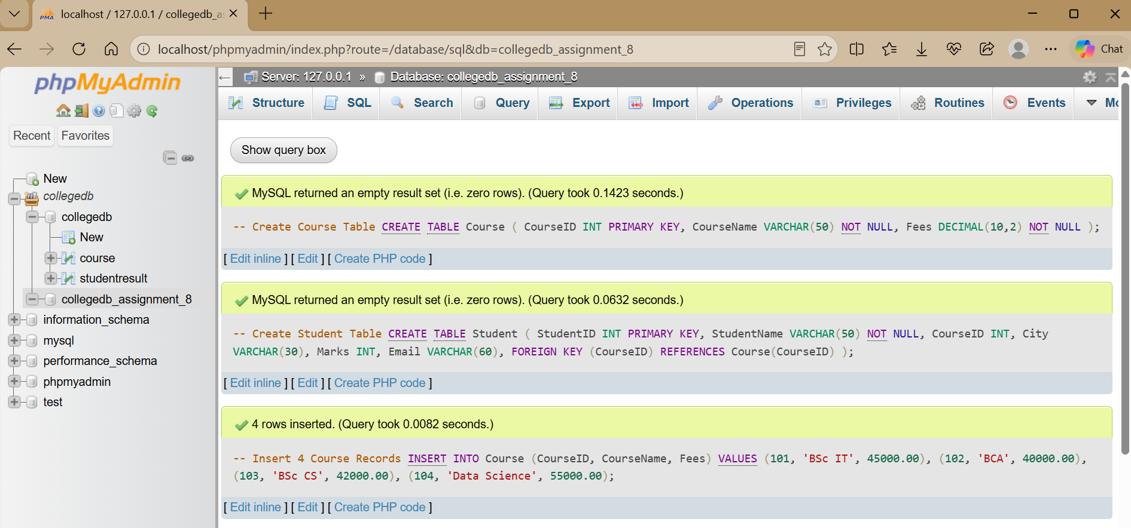

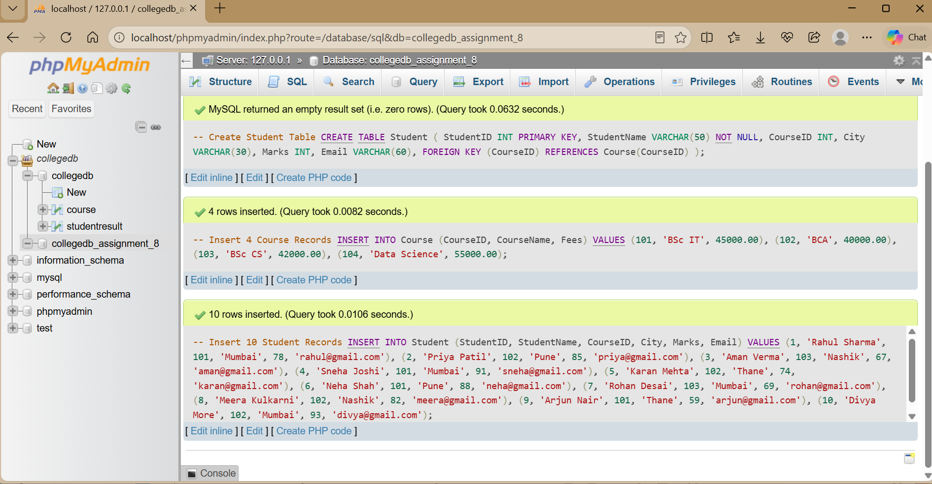

Q2) Create a view named StudentBasicView to display StudentID, StudentName, City, and Mark.

CREATE VIEW StudentBasicView AS
SELECT StudentID, StudentName, City, Marks
FROM Student;

SELECT * FROM StudentBasicView;

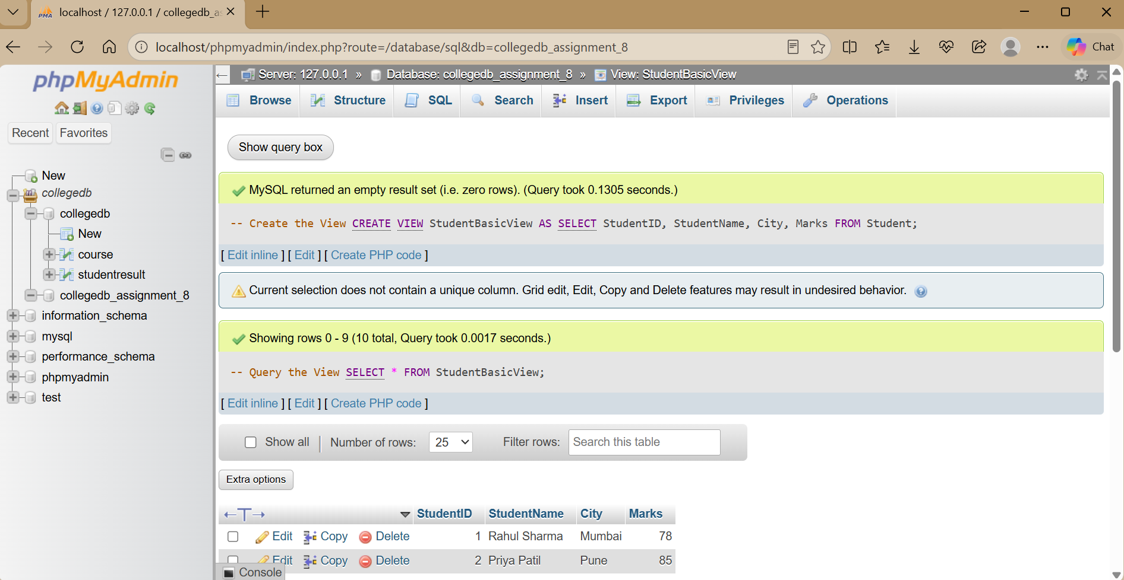

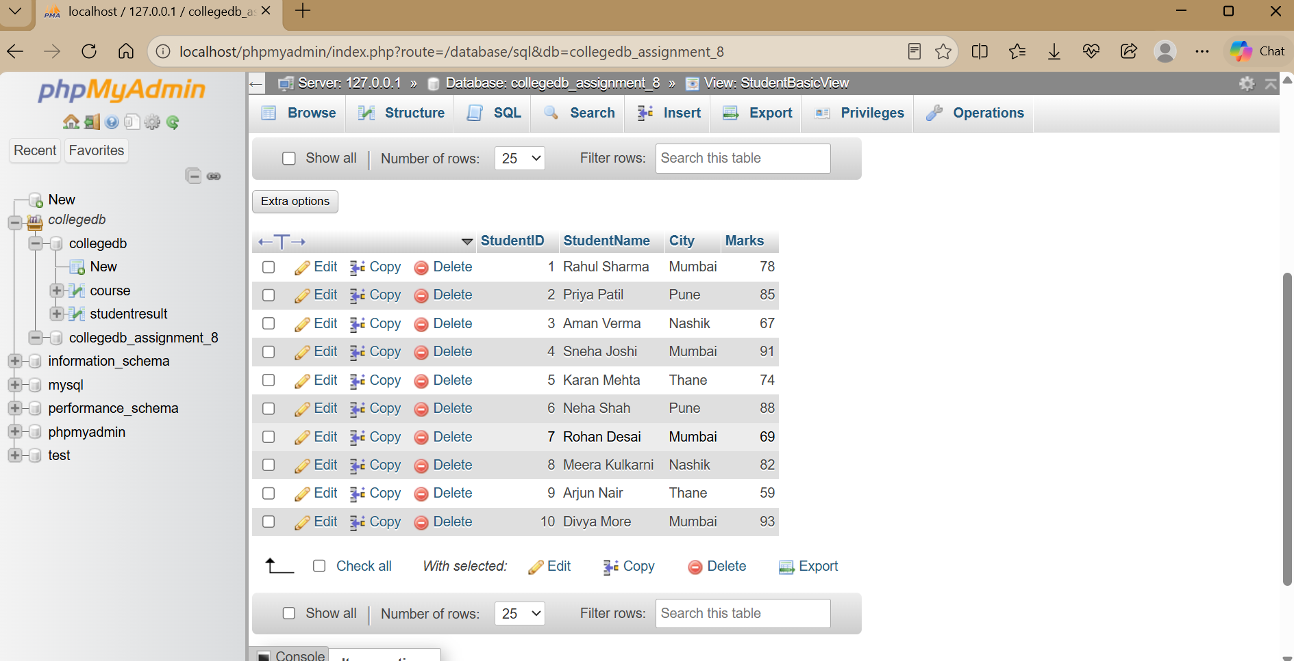

The view hides unnecessary columns and provides a simple reusable representation of student data

Q3) Create StudentCourseView using Student and Course tables.

CREATE VIEW StudentCourseView AS SELECT
Student.StudentID, Student.StudentName, Student.City, Student.Marks, Course.CourseName, Course.Fees
FROM Student INNER JOIN Course
ON Student.CourseID = Course.CourseID;

SELECT * FROM StudentCourseView;

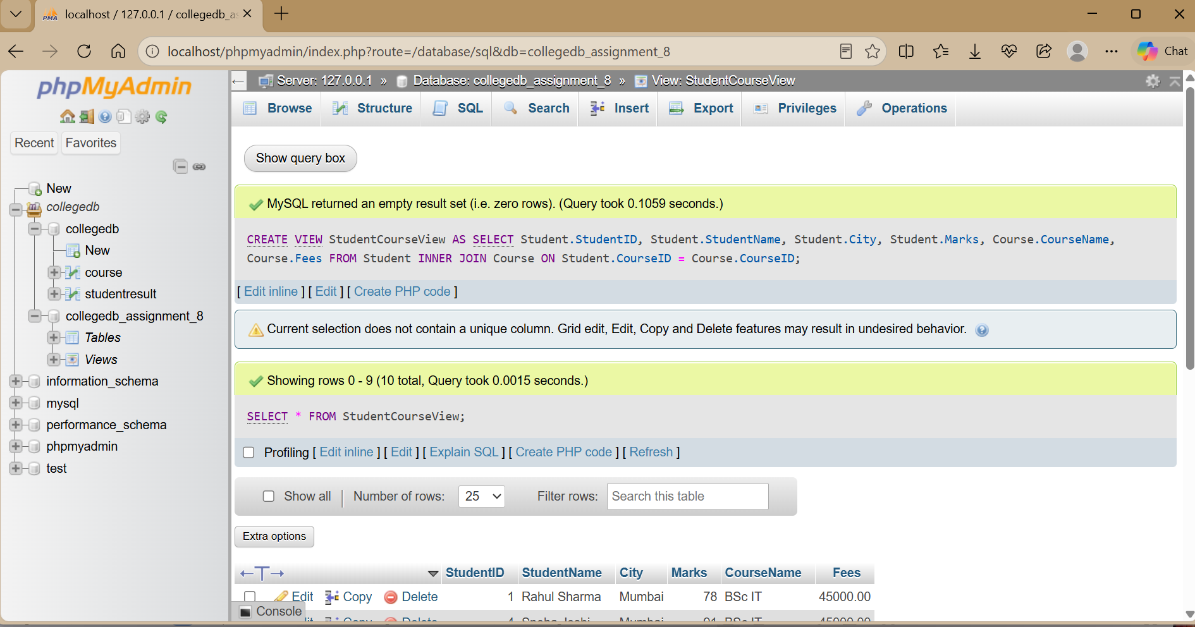

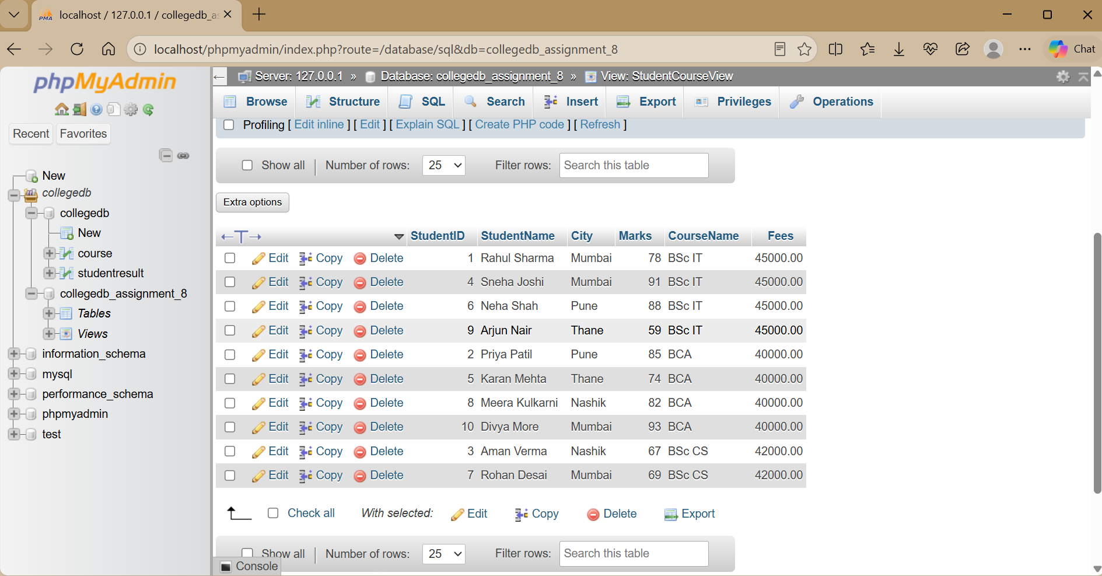

This view stores the query definition and allows the join result to be accessed like a table.

Q4) Display students from Mumbai using StudentCourseView.

SELECT StudentName, City, CourseName, Marks FROM StudentCourseView
WHERE City = 'Mumbai';

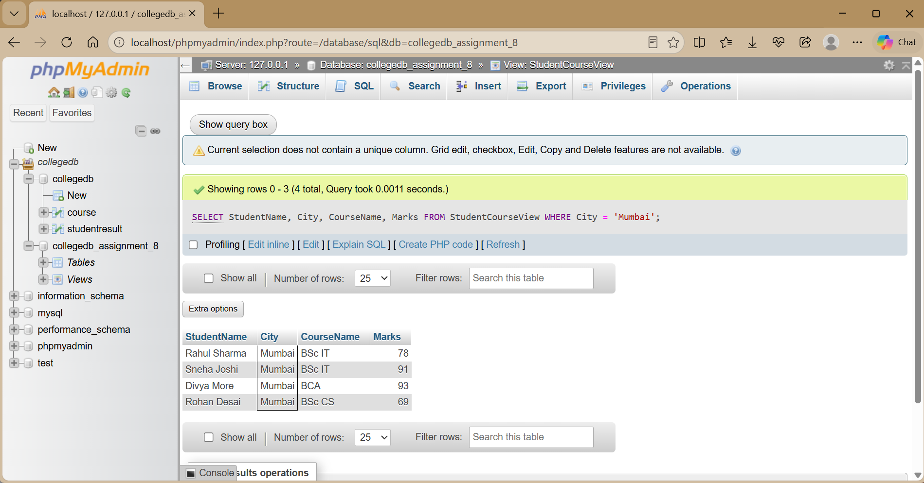

Q5) Display students sorted by marks in descending order using StudentCourseView.

SELECT StudentName, CourseName, Marks FROM StudentCourseView
ORDER BY Marks DESC;

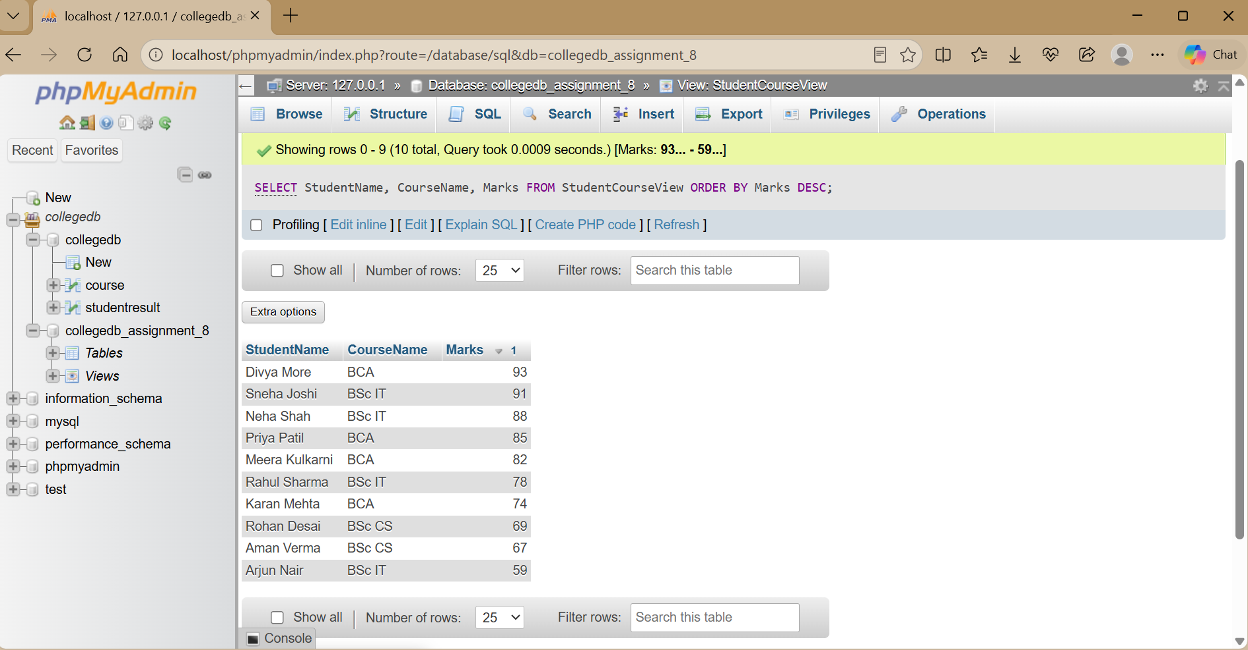

Q6) Create ManagementReportView showing course-wise summary.

CREATE VIEW ManagementReportView AS SELECT
Course.CourseName, COUNT(Student.StudentID) AS TotalStudents, AVG(Student.Marks) AS AverageMarks, MIN(Student.Marks) AS LowestMarks, MAX(Student.Marks) AS HighestMarks
FROM Course
LEFT JOIN Student
ON Course.CourseID = Student.CourseID GROUP BY Course.CourseName;

SELECT * FROM ManagementReportView;

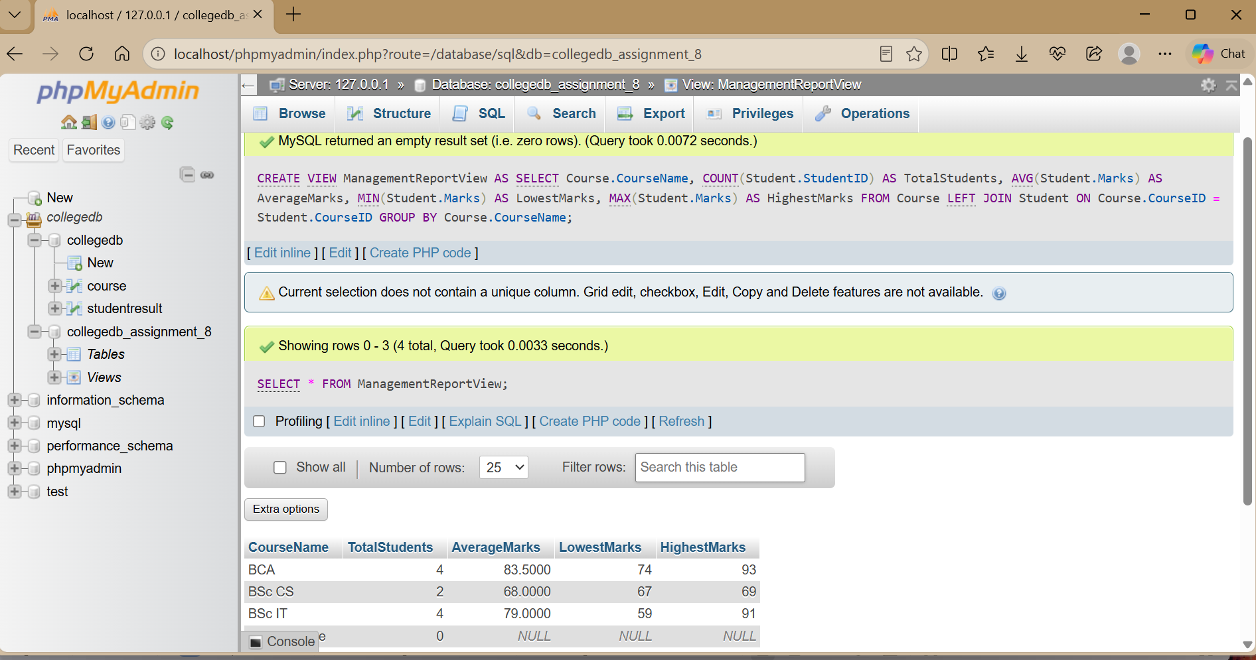

Why is this useful?
A report view stores complex reporting logic in one reusable object, making management reports easier to generate and maintain.

THANK YOU

